**Group 7 :**

* Alfin (1901457366)
* Felicia Stella (1901465733)
* Mery Angelya (1901460026)
* Stevanus Cornelius (1901478250)
* Triasadi Pranata (1901470102)

1. **Company Profile**

**Business Information**



* **Business Name:** Clothe & Clean
* **Business Address:** Kemanggisan Street No.170, West Jakarta
* **Email:** clothenclean@gmail.com
* **Tel:** 021-6327688

**General Business Activities** Clothe & Clean is established as a laundry service company in Kemanggisan Street of West Jakarta, Indonesia. Located at a densely populated and busy area, Clothe & Clean offers the assurance of fast, convenient, and professional laundry service. Clothe & Clean has different laundry service package options which are designed to best suit the customer’s needs. To ensure the service quality and professionalism, all the laundry operational transactions data are stored in a database specifically programmed to support the daily laundry service operations. All the products used in the laundry cleaning service are environmentally friendly products that efficiently clean every different type of fabric.

**Company Strategy**

* **Purpose** To be a leader in the laundry business by providing convenient and enhanced laundry services.
* **Vision** To provide quality laundry services that exceeds the expectations of our esteemed customers.
* **Mission statement** To build long term relationships with our customers and provide exceptional customer services through innovation and professionalism.
* **Core values**

• We believe in treating our customers professionally with respect and faith.

• We are eager to improve through our entire customer’s critics and advice.

• We grow through creativity, innovation, and technology in our services.

• We integrate honesty, integrity and business ethics into all aspects of our business services

* **Goals**

• Regional expansion in the field of laundry service business.

• Increase the assets of the company to support the development of services.

• To build good reputation of laundry service business and maintain long-lasting relationship with our customers.

**Business Process without System**

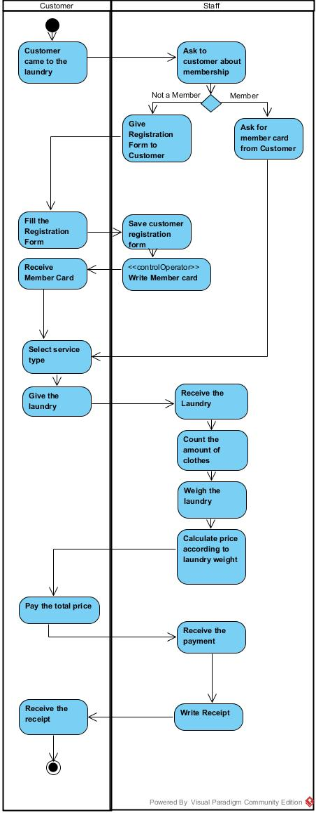

1. **Database Planning**

**Mission Statement**

1. To support customer data
2. To support the recording of transactions
3. To support accounting reports
4. To support analytical reports

**Mission Objective**

1. To support customer data
   1. Create customer data
   2. Display customer data
2. To support the recording of transactions
   1. Create data order
   2. Generate total price
   3. Create receipt
3. To support accounting reports
   1. Generate monthly revenue report
4. To support analytical reports
   1. Generate the most profitable month in a year report
   2. Generate the most frequent customer report

**Documentations needed to support the database**

1. Receipt
2. Registration form

**Data that will be recorded to the database**

1. Customer data
2. Staff data
3. Service type data
4. Sales data

* 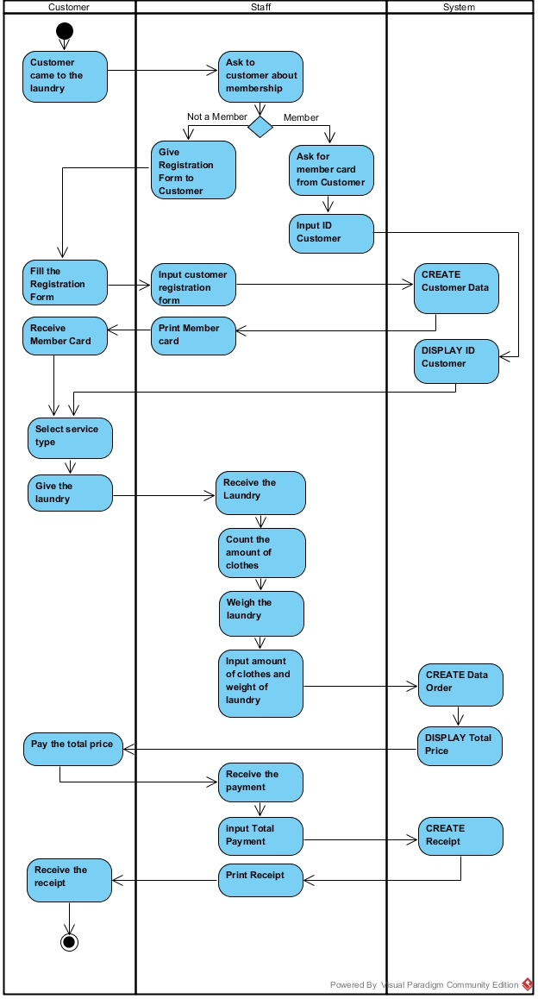**Business Process with System**

1. **System Definition**

|  |  |  |  |  |  |
| --- | --- | --- | --- | --- | --- |
|  | Customer | Staff | Owner | IT | Accounting |
| Sales |  |  | ✓ | ✓ | ✓ |
| Staff |  |  | ✓ | ✓ |  |
| Customer | ✓ | ✓ | ✓ | ✓ |  |
| Clothes | ✓ | ✓ | ✓ | ✓ |  |
| Service Type | ✓ | ✓ | ✓ | ✓ |  |

1. **Database Design**

* **Receipt**

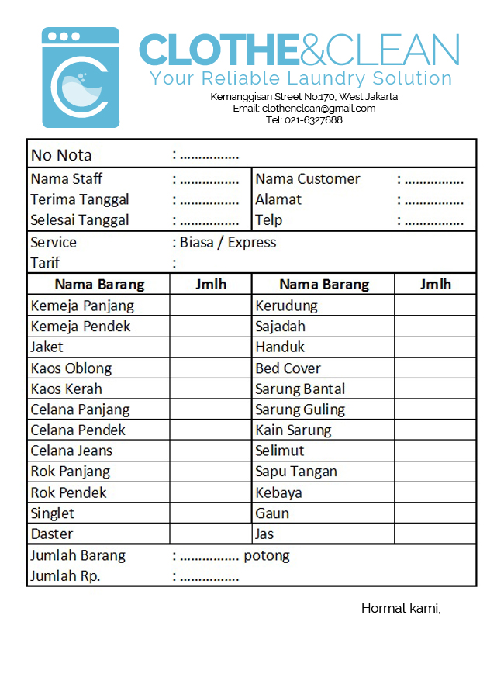

* **Normalization**

|  |
| --- |
| **UNF**  TrLaundry : (ID_Trans, tglTerima, tglAmbil, namaMember, alamatMember, telpMember, namaStaff, {namaBrg, jumlahPerBrg}, tarif, totalBrg, harga, serviceType_Name) |
| **1NF**  TrLaundry : (**ID_Trans**, tglTerima, tglAmbil, namaMember, alamatMember, telpMember, namaStaff, tarif, totalBrg, serviceType_Name)  TrDetail : (**ID_Trans**, **ID_Brg**, namaBrg, jumlahPerBrg) |
| **2NF**  TrLaundry : (**ID_Trans**, tglTerima, tglAmbil, namaMember, alamatMember, telpMember, namaStaff, tarif, totalBrg, serviceType_Name)  TrDetail : (**ID_Trans**, **ID_Brg**, namaBrg, jumlahPerBrg)  MsBarang : (**ID_Brg**, namaBrg) |
| **3NF**  TrLaundry : (**ID_Trans**, tglTerima, tglAmbil, totalBrg, ID_Member, ID_Staff, ID_ServiceType)  TrDetail : (**ID_Trans**, **ID_Brg**, namaBrg, jumlahPerBrg)  MsBarang : (**ID_Brg**, namaBrg)  MsMember : (**ID_Member**, namaMember, alamatMember, telpMember)  MsStaff : (**ID_Staff**, namaStaff, alamatStaff, telpStaff)  MsServiceType : (**ID_ServiceType**, serviceType_Name, tarif) |

* **Conceptual Database Design**

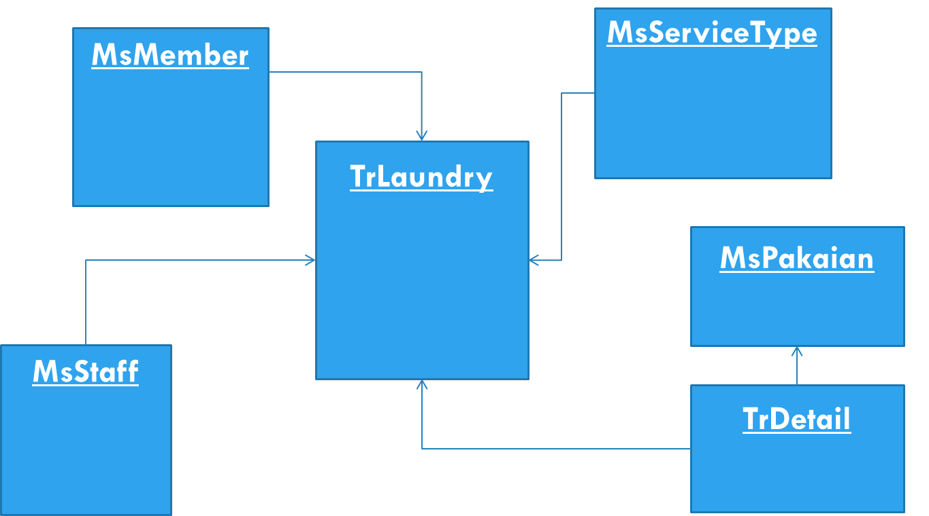

* **Logical ER Modeling**

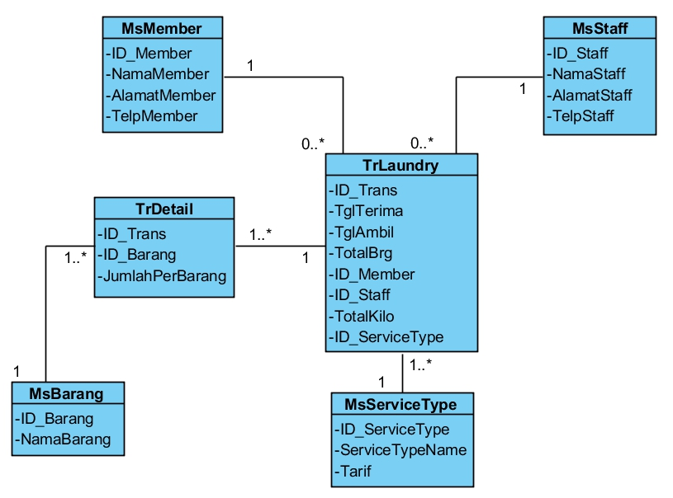

1. **User Interface**

* Home



* Member Registration

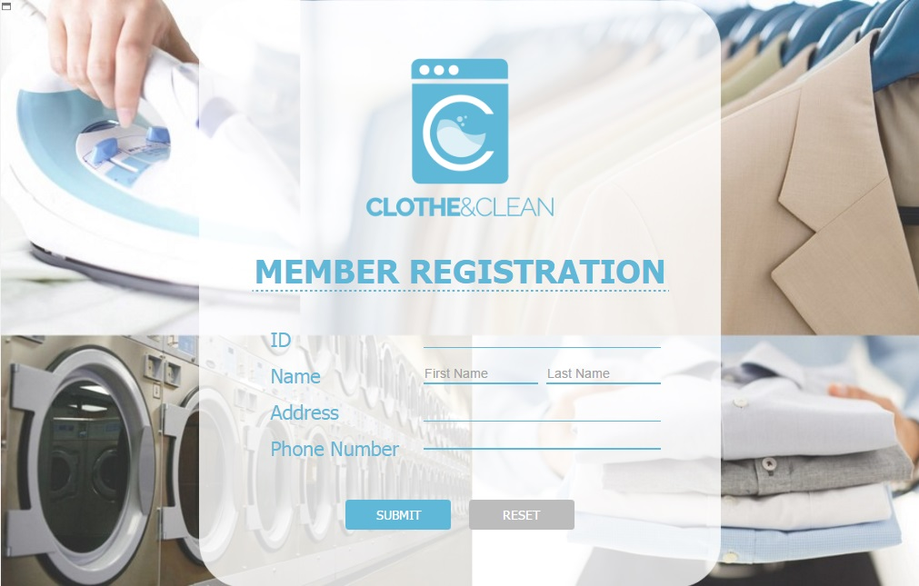

* Transaction

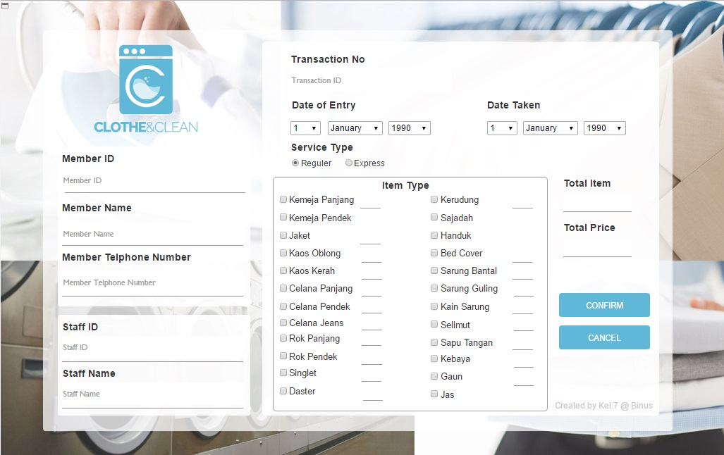

* View Data

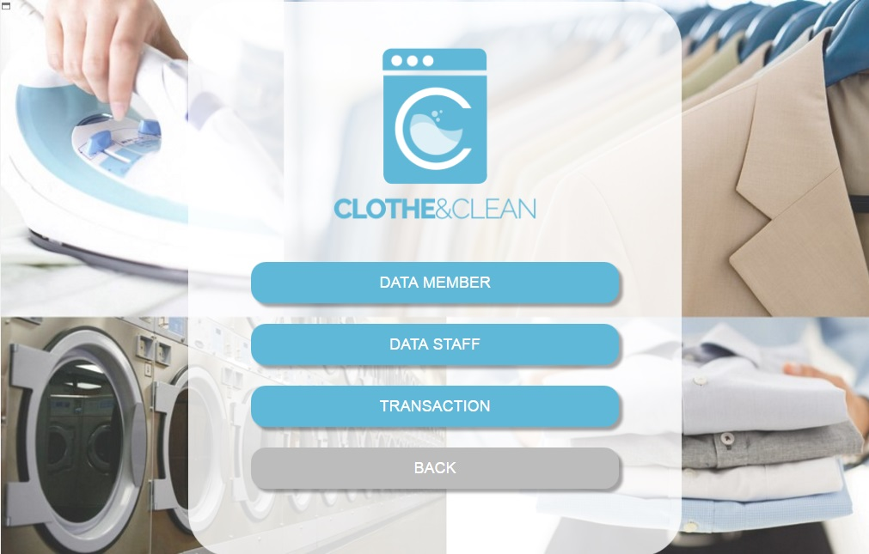

* MsMember

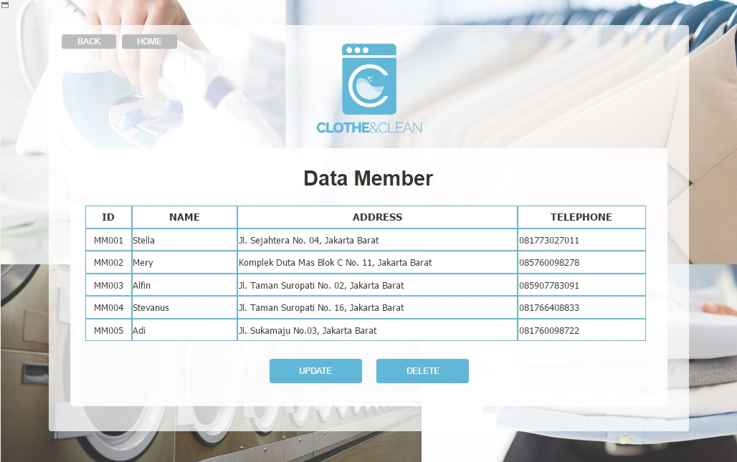

* MsStaff

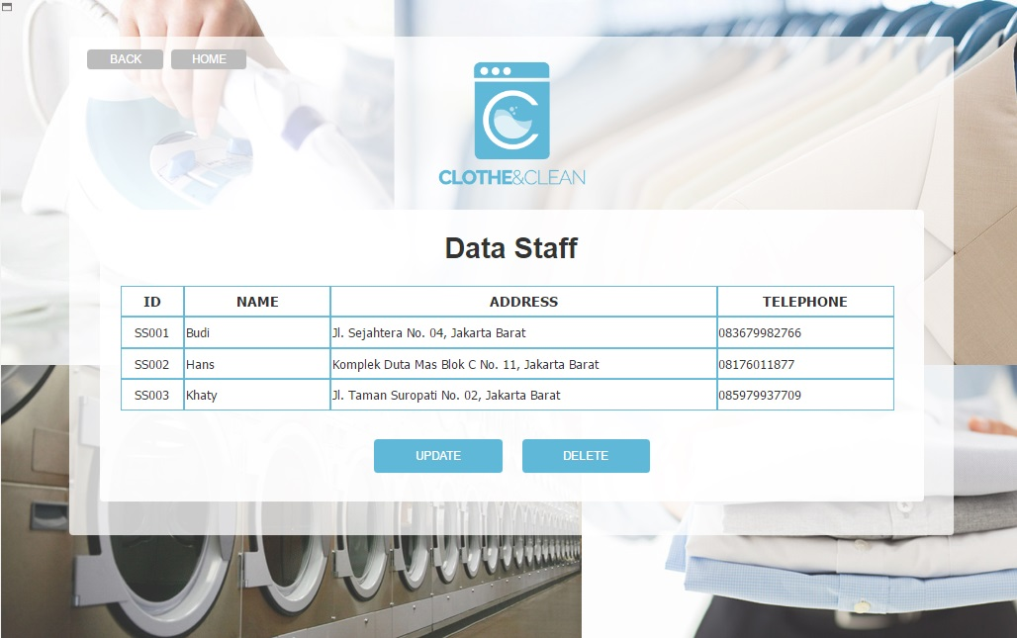

* MsTransaction

